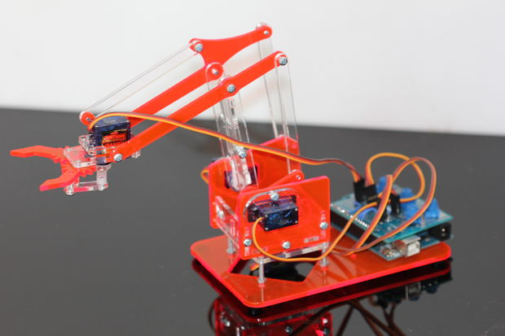Intro to Robotics with the UH Charter School

Figure : one robot arm built by UH roboticists

(30 minutes, ~6 college roboticists, ~22 Kindergarteners)

Supplies:

1. 6 robot arms (see image)
2. 18 Duplo building blocks.
3. Manila Folders with pictures of block arrangements
4. [NASA Swarmathon](http://nasaswarmathon.com/) robot

## Activity 1 (6 min): meet the robot arm, learn concept “Degrees of Freedom” and “workspace”

Setup one robot arm at each table, distribute 3-4 students to each table.

Roboticists run a demo program where the robot moves each axis. Roboticists introduce “Degrees of Freedom”

**Robot** arms are described by their **degrees of freedom**. This number typically refers to the number of single-axis rotational joints in the arm, where higher number indicates an increased flexibility in positioning a tool.

Roboticists ask kindergarteners questions:

* What is a robot?
* How could you add more “Degrees of Freedom” to this robot? What “Degrees of Freedom” would you add
* How would you change the robot?
* What area can the robot reach? (Introduce concept of ‘workspace’)

## Activity 2 (6 min): Control the human robot (forward kinematics)

1. Place 3 blocks on the table.
2. Select one student who will give commands for the roboticist’s shoulder, one for the elbow, one for the wrist, one for the hand. Student can say “shoulder up”/”shoulder down”, etc.
3. Roboticist closes eyes, and students pick one block for the roboticist to grab
4. Practice this activity twice, moving the blocks once the roboticist closes their eyes.
5. Compete between student/roboticist teams

## Activity 3 (6 min): programming a robot

1. Place 3 blocks on the table.
2. Select one student who is the ‘robot’
3. Show the other students a picture of the desired block arrangement
4. Students must give commands to their robot, but cannot touch the robot or the blocks
5. 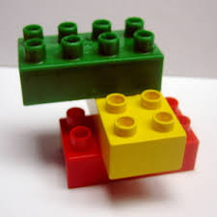Switch student who is the robot

Figure , duplo block structure

## Activity 4 (4 min): show the NASA Swarmathon robot

1. Show robot, roboticist explains the contest rules (quickly)
2. Take a picture with the NASA swarmathon robot